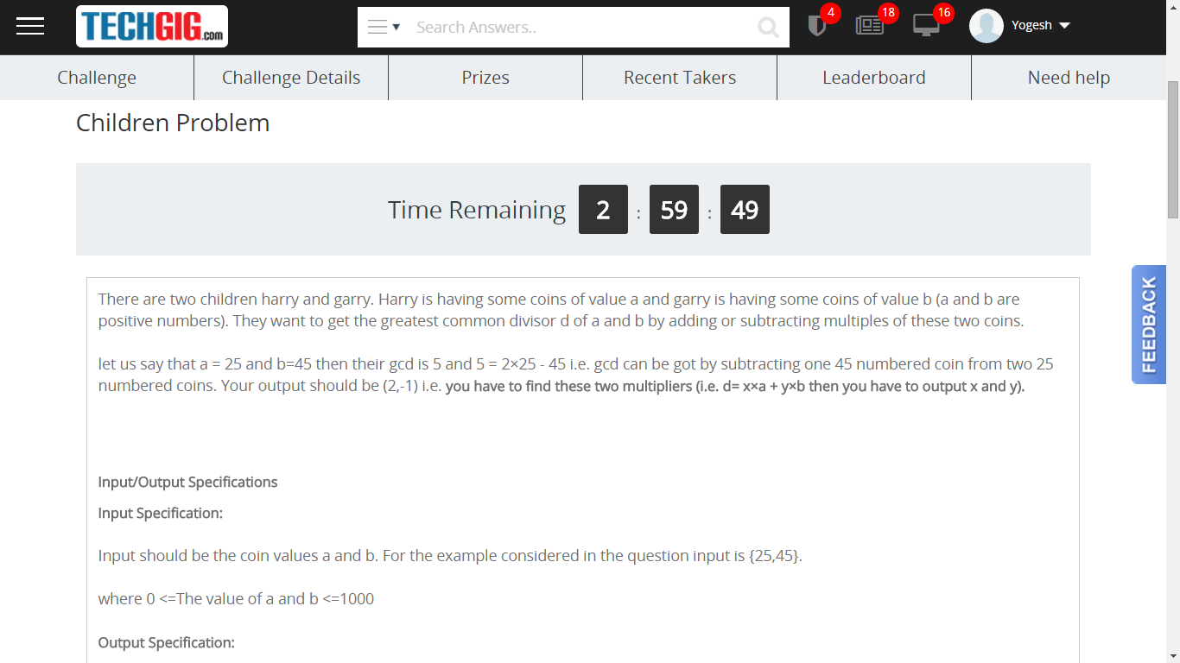

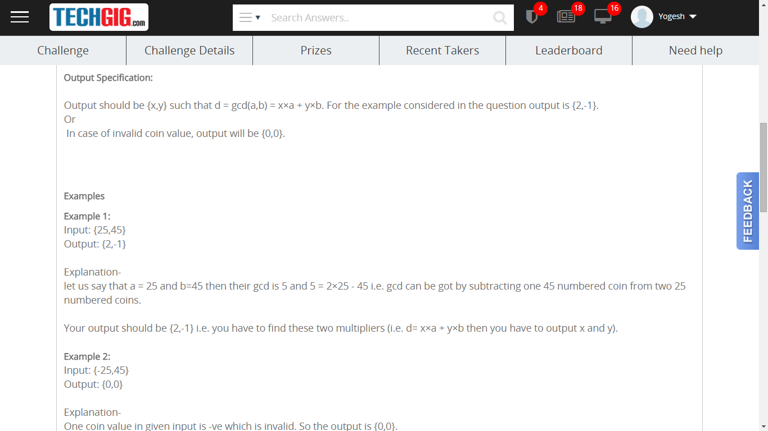

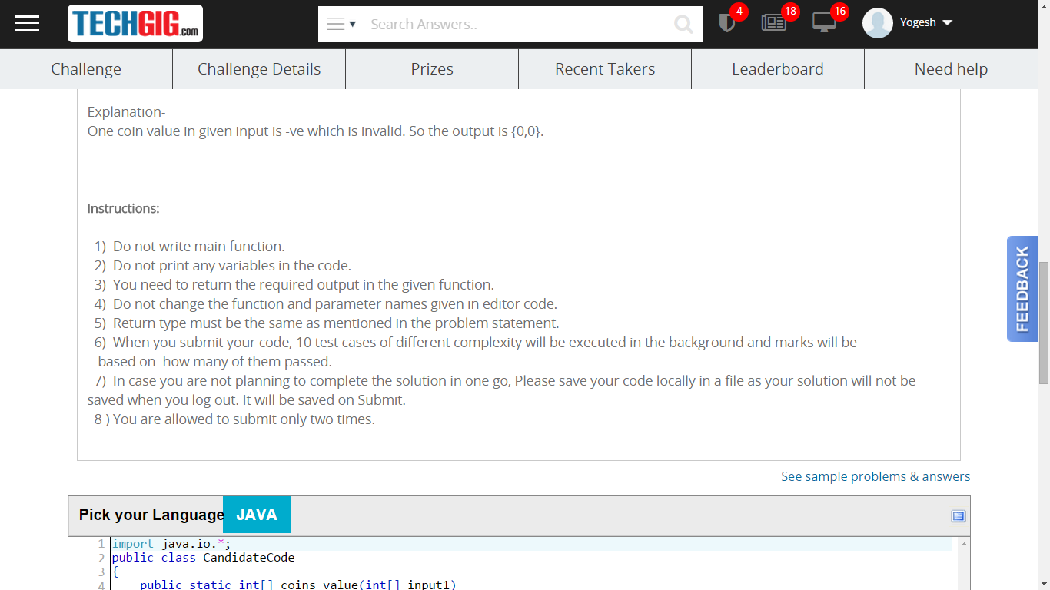

|  |
| --- |
| import java.io.*;  public class CandidateCode  {  public static int[] coins_value(int[] input1)  {  //Write code here  }  } |